Updates 01Jun2026

Item #1

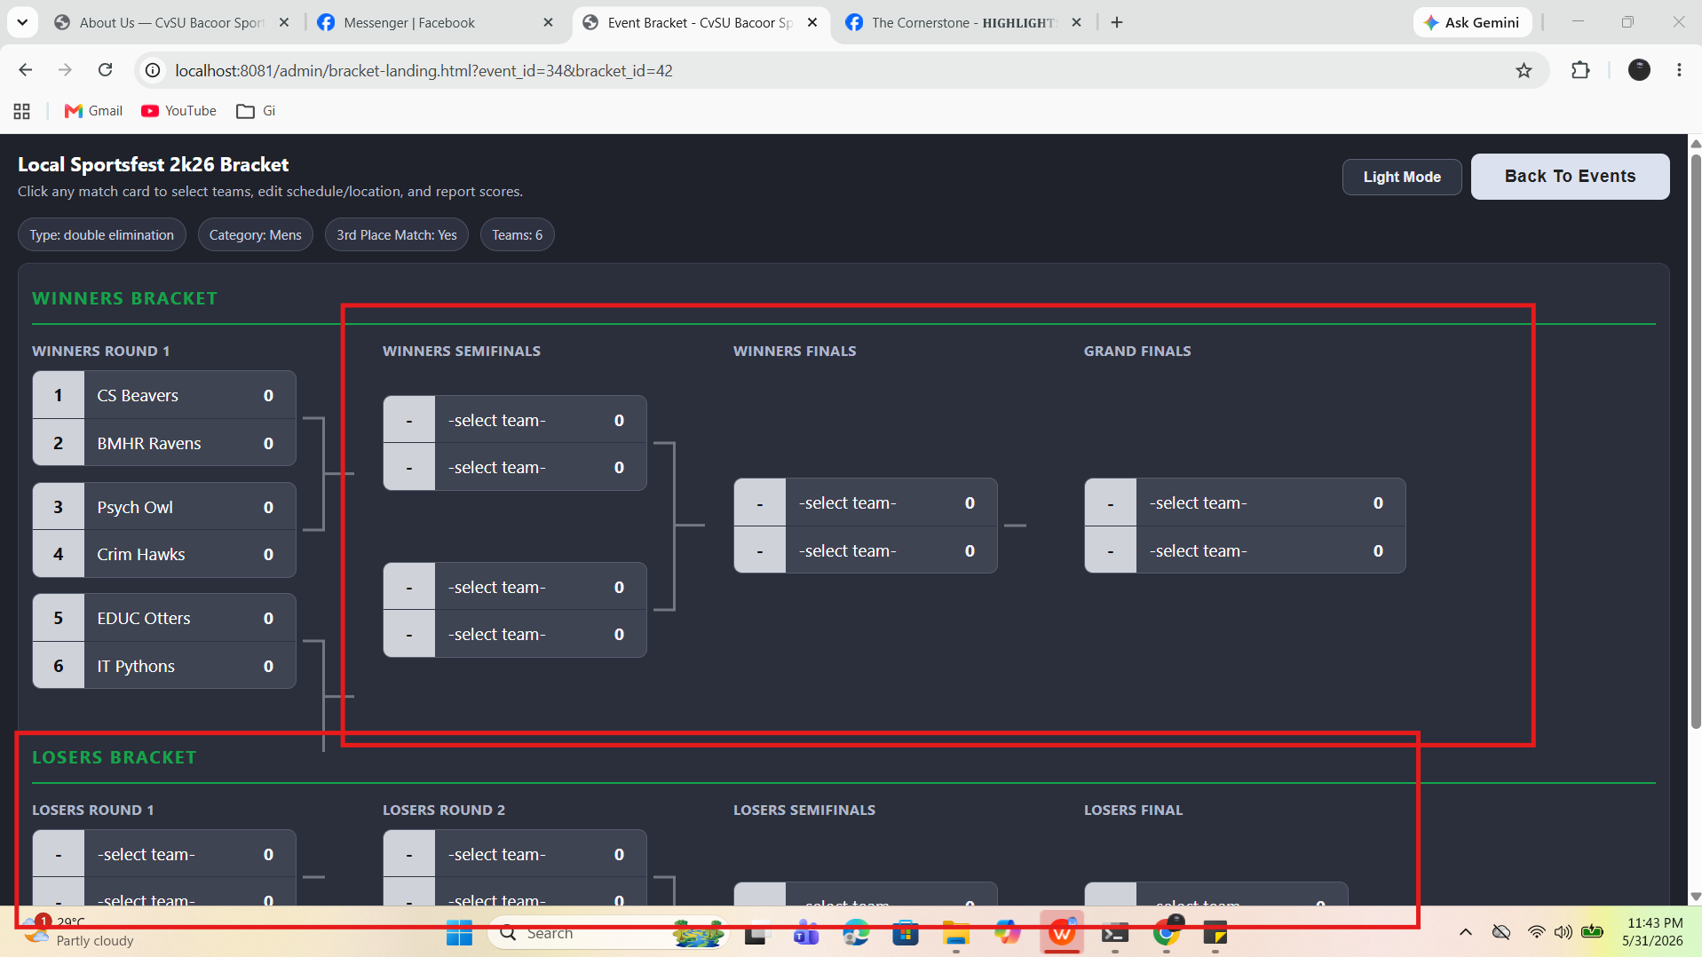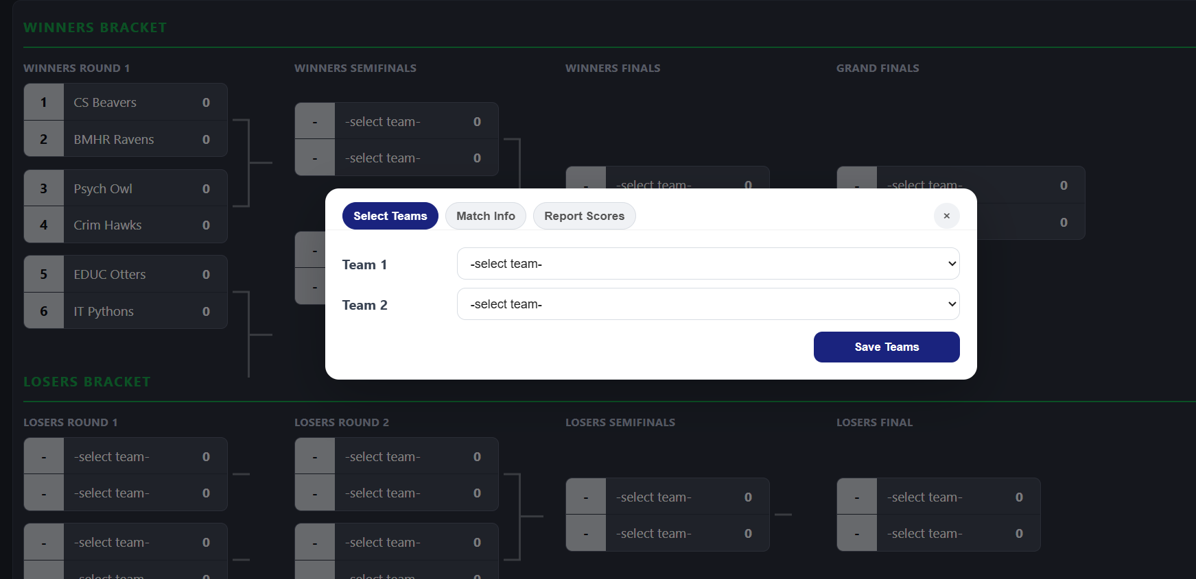
If pwede po I-disable yung select teams dun sa nakabox na part ng bracket nagkaron po kasi ng bug wherein nag set ng team 1 and team 2 dun sa next stage ng bracket and di napo matanggal yung team 1 and 2 di na nasunod yung point progression po.

Comment:
Status: Updated
Changes:
- Manual team selection is limited to first round only for elimination formats.
- Non-first-round unresolved slots changed to TBA.
- Round 2+ elimination matches now hide Select Teams and Report Scores when either prerequisite is missing:
1) feeder winner not yet decided
2) both teams are not yet complete
- Tab switching hardened so hidden tabs cannot be selected.

Item #2

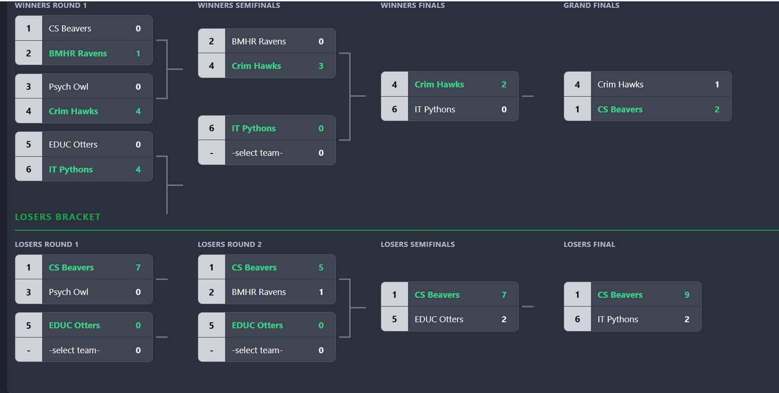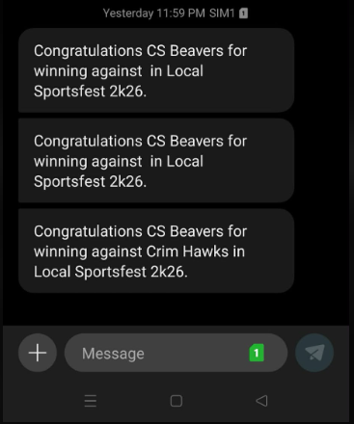

Then dito naman po yung sa SMS di siya consistent since di showing yung opponent sa mga naunang games.

Comment:
Status: Fixed
Changes:
- Strengthened winner/loser name resolution in winner SMS generation.
- Added fallback logic based on registration ids and direct team lookups when joined names are empty.
- Added template variable aliases for loser placeholders (for broader template compatibility).
- Expanded placeholder parsing support to tolerate more placeholder styles.
- BYE-specific behavior updated:
1. BYE auto-advance state has persisted, so backend context stays in sync
2. automatic winner SMS is now skipped for BYE matches

Item #3

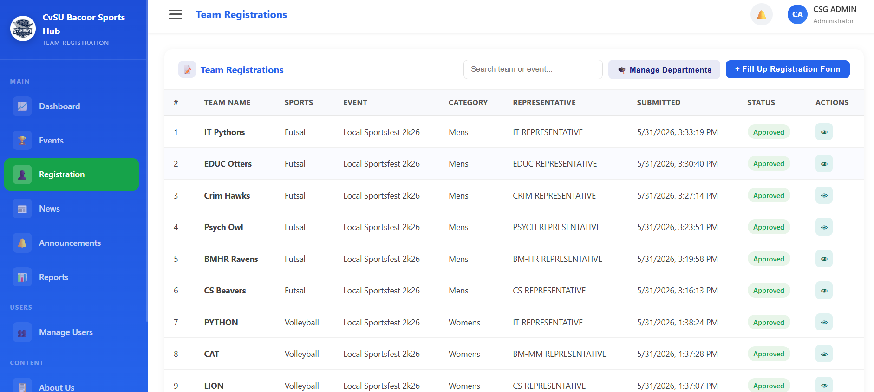
Then on this part po if pwede mag add ng action such as delete and update. Then if may delete po may message prompt lang po yes or no to continue with deletion.

Comment:
Status: Added
Changes:
- Added admin Edit Status/Comments capability from registrations table.
- Added admin Delete action for registrations.
- Removed restriction that only Pending requests can be changed; admins can now change already Approved entries to Rejected (or any supported status).
- Added modal for editing status and review comments.
- Extended status API to persist notes/comments during status update.
- Added registrations delete API endpoint.
Then other items po are the following

Item #4
- Admin access under Event is it possible po na mag prompt if yung Date, Time and Location is the same like “It shows that a same event will happen at this time and location. Are you sure you would like to continue?”

Comment:
Status: Added
Changes:
- Added create/update conflict check for same start date-time and location.
- On conflict, save now prompts exactly:
- "It shows that another event is scheduled for the same date, time, and location. Are you sure you want to continue?"
- Save proceeds only when user confirms.

Item #5
Forgot password, hindi po siya functional

Comment:
Status: TBD
Options:
- Remove the forgot password link in Login Page. (Recommended)
- Security questions will be set upon account sign-up. (Additional fee)
- OTP for password reset. (Additional fee)

Disclaimer:
The additional fee is not fixed; it depends on the scope of the requests.

